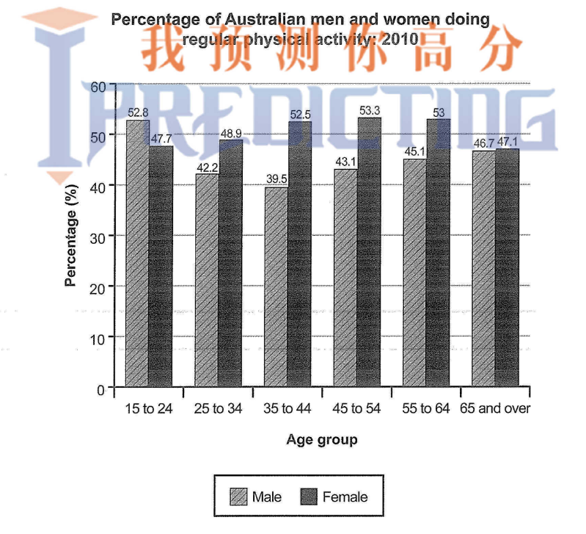
The bar chart illustrates the proportions of Australian men and women in various age group who performed physical exercises in year 2010.

Evaluating the above diagram, the percentage of female ,at the age group 55 to 64, performing physical activities is observed to be at peak

